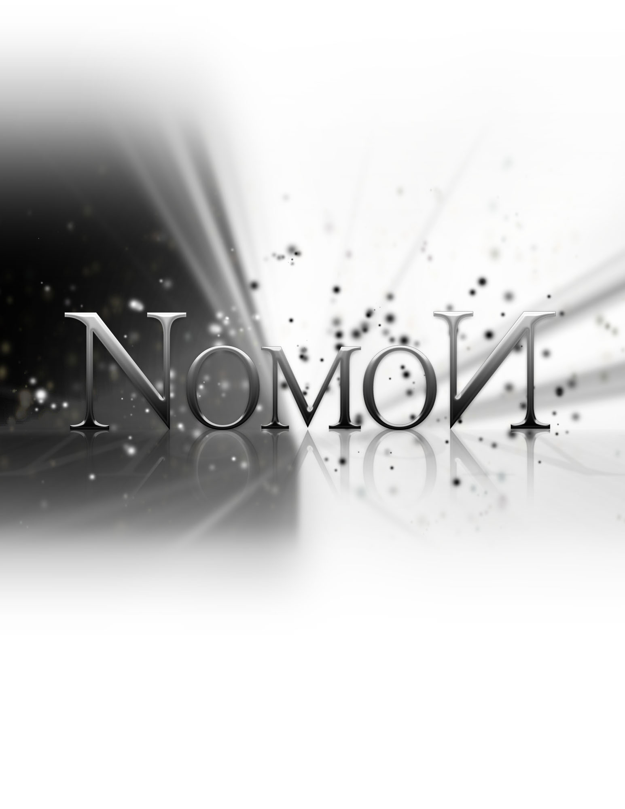
Status Report

Friday, November 18, 2011

Status Report

The List of Tasks to be done by this period:
  - Ready for Alpha Testing – November 4th 2011
  - Alpha Test, Advertisement and Improved Website – November 15th 2011

Tasks underway:

Concept Art - 100% Complete
Worked on by Sarah (20%), Shaughn (30%), Adam (10%), Tom (10%)

Art Research - 100% Complete
Sarah (40%), Shaughn (60%)

Platformer Tutorial - 100% Complete
Nik (30%), Adam (30%), Tom (40%)

Web Design - 100% Complete
Shaughn (50%), Sarah (20%), Adam (30%)

Modelling - 80% Complete
Tom (5%), Sarah (10%), Shaughn (50%), Adam (15%)

Re-Rigging - 100% Complete
Sarah (100%)

Level Design – 90% Complete
Adam (50%), Nik (50%), Tom (50%)

Level Building - 50% Complete
Tom (25%), Nik (25%)

Animation – 90% Complete
Sarah (90%)

UDK Custom Character – 100% Complete
Tom (50%), Sarah (50%)

Promo Material – 66% Complete
Sarah (50%), Shaughn (16%)

File Organization – 100% Complete
Adam (50%), Tom (50%)

UDK Custom Classes – 80% Complete
Tom (75%), Adam (5%)

UDK Level Transitions – 60% Complete
Tom (30%), Sarah (30%)

Alpha Testing – 100% Complete
Sarah (40%), Adam (15%), Tom (15%), Nik (15%), Shaughn (15%)

Sound and Music – 20% Complete
Shaughn (20%)

We will need to implement the following functionality:
- Object carrying mechanic: Certain objects need to be able to be carried. Developers need to simply code in a few triggers and have a supporting character animation to enable this.

We also need to finish building the levels, including adding pretty assets, play test the platforming physics, fine tune the lighting, implement the shaders and sound effects.

List of Tasks Accomplished by their appropriate date:

- Character animation
- Promotional material
- Updated website

List of delivered results of the tasks (files, etc)

- Maya Binary – updated character model and rig, promotional animation scene
- FBX – level assets
- UDK Files – custom classes, levels
- Images – level designs

Challenges and problems faced

Computer Permissions
We are now using custom UDK libraries – however, we do not have permission to update the UDK files on the computers to make use of these scripts. (The scripts need to be rebuilt)

Solution: work off of laptops – though not everyone in the group can do this

Maya/Wings3D/UDK Scale
Maya and Wings 3D have a much smaller scale than UDK, so there were compatibility issues with all of the models. Everything had to be resized, which was especially difficult with the animated player character.

Solution: work with the correct scale for future assets, now that we know the difference

